The Queen’s Hall Edinburgh
85-89 Clerk Street
Edinburgh
EH8 9JG
0131 669 3456

www.thequeenshall.net

Hall Specifications

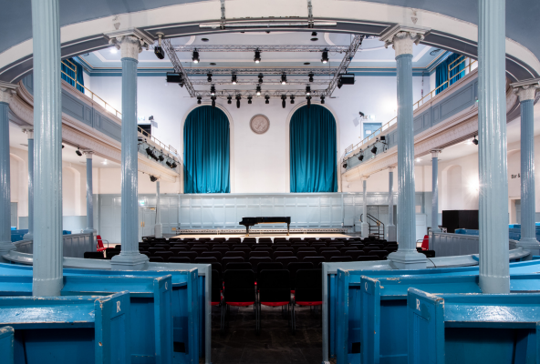
Contents

Main Contacts 2

Hall Capacities and stage set-up 3

Facilities 7

Stage 9

Power 10

Sound 11

Projection 12

Lighting 13

Rigging 14

Parking 15

Marketing 19

Main Contacts

Events Manager
Kris Bruce
krisb@queenshalledinburgh.org

Technical Manager
Tarquin Penman
stage@queenshalledinburgh.org

Marketing Manager
Emma Mortimore
emmam@queenshalledinburgh.org

Duty Manager
Jackie Caldwell
duty@queenshalledinburgh.org

Bar Manager
George Barr
bar@queenshalledinburgh.org

Box Office Manager
Peter Horne
boxofficemanager@queenshalledinburgh.org

Chief Executive
Evan Henderson
evanh@queenshalledinburgh.org

Finance
Mark Wheelwright
markw@queenshalledinburgh.org

Hall Capacities & Stage Set-ups

Once we know your exact set-up, we can give you precise numbers. The following is a general guide to The Queen’s Hall’s overall capacity.

900 Standing (unreserved)
801 seated (inc 107 ltd/non view)
773 cabaret seating (inc 107 ltd/non view)

Seating in centre stalls is either rows or tables (cabaret). Larger stage floors require the removal of centre stall seats, counted as part of the 107 ltd/non view.

Limited view gallery seating.
Please note that due to the design of the building, stage set ups that require the main artist(s) to be off center position on stage will cause sightline issues for the balcony seats.
This mostly affects the seating highlighted in blue below.
Additionally, please advise as soon as possible if the use of and ground stacked PA is to be used as this causes sightline issues for downstairs seating of the following seats: P23-25 and 60-63, Q20-23 and 62- 65, R17-20 and 65-68, S13-14 and 69-72, T13-16 and 69-72

Stage A – Rows
816 capacity | 709 unrestricted + 107 restricted

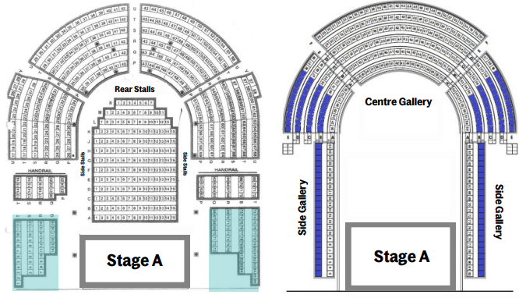
Stage B – Rows
801 capacity | 694 unrestricted + 107 restricted
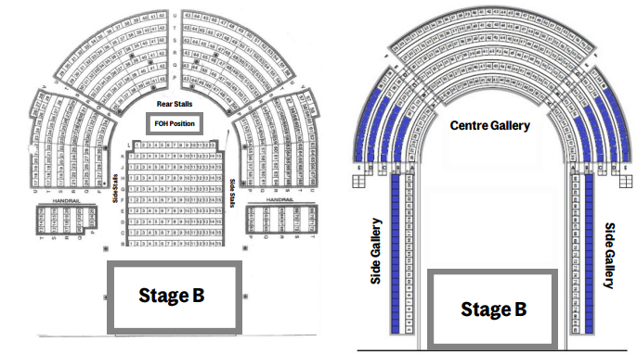

Stage C – Rows
785 capacity | 678 unrestricted + 107 restricted

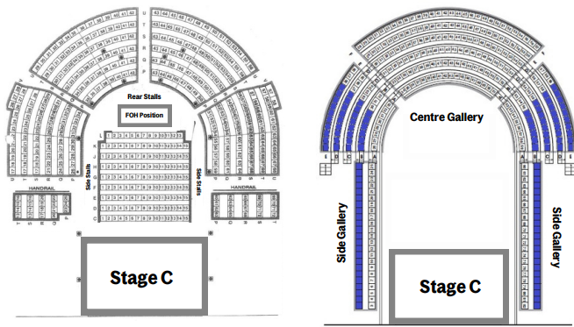

Stage B – Cabaret Tables
751 capacity | 644 unrestricted + 107 restricted
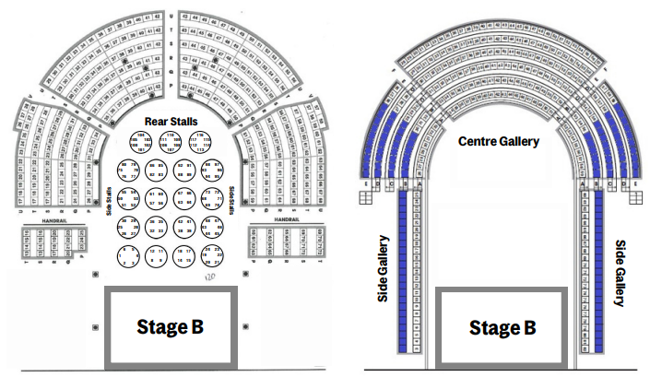

Stage C – Cabaret Tables
731 capacity | 624 unrestricted + 107 restricted

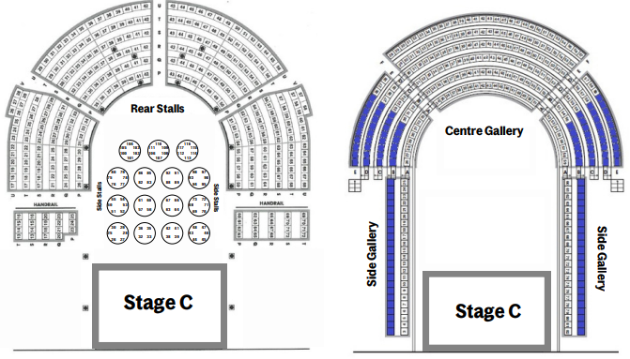
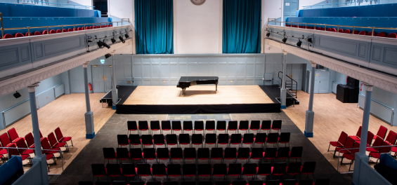
Stage set-up: Seated Rows

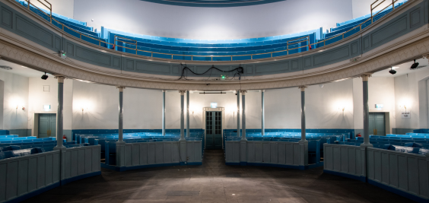
Stage Set-up: Standing

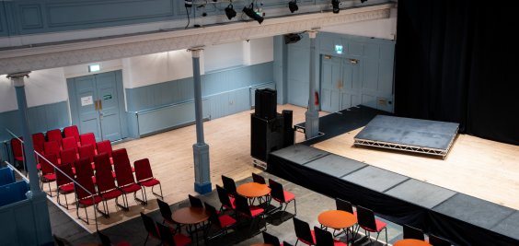
Stage Set-up: Cabaret Tables

Facilities

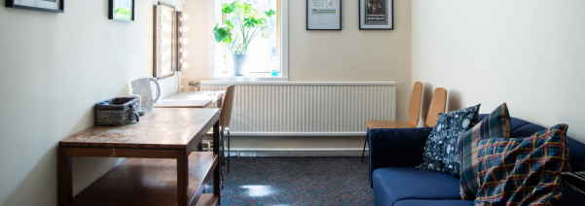

Artist Rooms 3 en-suite rooms (toilets and showers); capacity 8 people max

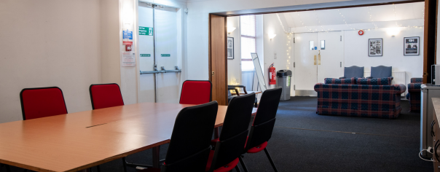

Green Room 1 large room behind stage with sofas, tables and chairs, fridge and tea/coffee making facilities

Production Office 1 large office with internet port

There are additional toilets and showers next to the Green Room and Production Office.

Wifi Available throughout the building. Password will be provided on request

Towels Max 20 on site – white and black available

Catering Buy outs only
NO COOKING BACKSTAGE as per instruction of Lothian and Borders Fire Brigade
Fridge available in the green room. Tea/coffee making facilities available in the green room and in all dressing rooms.
Merchandising Space available in the main corridor
Non-negotiable 15% fee
Please advise as soon as possible if you require a seller, we may be able to provide for a fee
A merch board is provided for display. Four hooks are provided across the top for hanging; pins should be used elsewhere on the board. If you want to display elsewhere, please speak to a member of staff first and do not put blutack on the walls
No venue card machines available, but a closed WiFi network is available if you wish to bring your own systems

Crew Professional crew available from Edinburgh Showtec – please ask for a quotation. Must be booked in advance.

Security None on site – MINIMUM 2 MUST BE BOOKED (Rock Steady)
Please discuss any specific security requirements with venue contact
Please note some shows may require higher security deployment based on profile

Barrier 3 bike racks on site, for FOH position only
Stage barrier – must be hired in if required (standing shows only)

Fire Curtain No

Stage Setup No Proscenium Arch or Wings

Stage Risers Selection available, to be discussed in advance. No extra cost.

Show times Provided as a guide only:
Box Office opens 90mins prior to show
Doors + Bar open 60mins prior to show
Show End – 22:45
CURFEW – 23:00 due to residential district
Venue must be vacated 90mins after show finishes

Delivery Address Box Office
The Queen’s Hall
85-89 Clerk Street
Edinburgh EH8 9JG

Music Shops Scayles is within a 3 minute walk of the venue, and Varsity Music within a 10 minute walk
For electricals, Euronics is within a 5-minute walk. All are found by turning left out of the front of the building.

Hotel Deal We have partnered with the University of Edinburgh’s Accommodation team to offer up to 15% off stays in their 4-star hotels, The Scott and The Scholar, 3-star KM Hotel and self-catering KM Apartments. Find out more about this on our website.

Stage

Load-in access Through narrow centre door at Clerk Street. Approx. 2m high by 1.5m wide. Ramp from street level available.

Stage details 9.75m wide
Stage depth is available at A. 4.4m, B. 5.6m, C. 6.8m or D. 8m 0.6m high
Clearance approx. 7.5m to nominal flying of truss
Platform stage, no proscenium
No PA wings and stage wings are not able to be boxed off
Black back drop available, 7.5m (h) x 9m (w)
6x metal 12.5kg Stage weights
Stage risers LiteDeck Toplock, must be arranged in advance
6x 8’x4’
4x 4’x4’
2x 2’x4’
Riser legs available at 1’ (0.3m) or 2’ (0.6m), must be agreed in advance
6x wooden box risers 1.08m x 1m x 0.3m
2x wooden box risers 77cm x 52cm x 20cm

Mixer and lighting positions - rear of centre stalls in front of pews.
Cable runs stage to FOH along the balcony. No more than 40m.
6x Comms boxes with headset units – mixture of single ear and double ear headphone.
Positions located at FOH Control, Upstage Left, Backstage Left, Upstage right, Backstage Right, and Upstairs Centre Gallery.
DMX in ports located at FOH position and just off stage left (no more than 8m) for patching. One DMX 512 universe in house with channels 001-453 used for in house fixtures.
In house analogue XLR multicore available for use upon request.
In house single Cat6 available.
Stage left available for monitors set up.
(Space off stage right is also available, though a path must be kept clear as this is a fire escape access).
Limited storage space available along corridor off stage right. Access route, highlighted by yellow markings, MUST be kept clear as this is a fire escape.

5x wooden treads
1x hand railed steps

All positions MUST be agreed in advance of going on sale. It is our policy that once tickets have been sold, we do not re-seat customers from the best seats in the house to accommodate configuration changes.

Power

Power 2x 63amp 3phase CEE Form,
Or 1x 63a 3phase and 3x 63a single phase CEE Form,
Located 8m cable length off stage left

Backline Power 2x 13amp sockets on upstage wall
1x 16amp socket upstage left wall

FOH House Power FOH house power 1x16a socket trails from balcony

Cabling and Extensions Selection of 16a power extensions of varying lengths
7x Power stage boxes with 16a through and 4x 13a sockets
Selection of varying length 13a plug/socket extension cables

Distro 32a Single Phase

Tour Bus Info No overnight shore power. Access to the front is only available 09:30-16.00 and 18:30-00.30. Outwith these times you will NOT be allowed to stop.

Please note that dispensation will be needed per vehicle stopping. This is £20 + VAT per vehicle, charged back at settlement. Details required a minimum of 48 hours before the show. See our website for more details.

Sound

Mixing Desk Allen & Heath D-Live C3500
Allen & Heath CDM48 Mix Rack (48in, 24 returns)
Yamaha LS9-32
Stage box upstage Left wired to FOH position (23in, 6 returns)

Multicore Cat6 drum and cable run from Stage to FOH
23 channel analogue xlr inputs + 8 xlr returns

PA Downstairs:
2 pairs Nexo Geo S1230 main – ground stack
1 pair Nexo S2 Subs – ground stack

Gallery:
1 pair Nexo Geo S1230 main - flown upstairs
1 pair Nexo PS8 outfill - flown upstairs

Monitors/front fills:
8x Nexo PS15
4x Nexo PS10 (often used as out/front fills)

Nexo NX242 digital System controller
Camco Vortex 6 amplifier - main
Camco Vortex 6 amplifier - subs
Camco Vortex 4 amplifier - monitors
Samson S2000 amplifier - monitors
Nexo PS15TD Controllers
Nexo PS10TD controller
Nexo PS8TD controller
QSC 4 channel – flown outfills
QSC 4 channel – monitors/outfills

Mics 8x SM58
2x Beta58
8x SM57
4x Beta57
6x AKG C451
4x Beta98
2x E906
1x Beta91
1x Shure B52
2x DPA 4099P with Piano mount
4x DPA 4099 with violin mounts 7x BSS DI boxes

Stands Stands 19x Tall tripod mic stands
9x Short tripod mic stands
1x Tall Round base mic stand
1x Bass drum mic stand
2x A-Frame Guitar stands
20x Black solid music stands

Piano Steinway D Full size Grand Piano 2001
Steinway D Full size Grand Piano 2014 (only used for classical)
Kemble Upright Piano
3x adjustable piano stools

Misc. CD Player

50 x black armless chairs

1x wooden, soft seated bar stool
6x Tall barstools with backrest

Conductor’s podium – 1.3m x 0.68m x 0.23m (with back rail and carpet)

Drum carpet 8’ x 5’

4x square wooden top table 68cm2 x 74cm high

Black cloth varying sizes

Projection
Please indicate if projection is to be used prior to tickets going on sale, to allow us to advise any sight line issues. We do not have any in house projection, or cabling. All screens, projectors and data cables must be hired in.

Please note that rear projection is not recommended in this venue and will take out most, if not all of the performance area on the stage. If a larger stage is selected at the time of booking to compensate for this, please note that we do not have any means of masking off the sides of stage between the rear of the screen and the projector. The area for the projector is also not recessed.

Lighting

Control Chamsys MQ40N
1x Wireless control box for house lights
1 DMX 512 universe in house
DMX at FOH position
DMX in and out off stage right with approx. 8m cable run to stage.
4x DMX on Truss cross beams

Power Rack ColorSource ThruPower Cabinet 24x10A
ColorSource ThruPower Cabinet 12x10A
6 x 16amp single phase hot power sockets

Fixtures 14 - Briteq Orbit
8 - Briteq Saturn
12 - Briteq Theatre each with barn doors
10 - ParNel*
4 - 14deg Source 4 Profile *
4 - 19deg Source 4 Profile *
(*- Upon request only)

Gels available in a range of colours

Please email stage@queenshalledinburgh.org in advance for a current patch sheet of the rig.

Please be advised we have no designated follow spot positions available. If follow spots are required, please discuss this with us before going on sale. We do not recommend the use of follow spots due to disruption/proximity to the audience and resultant loss of capacity and the loss of approx. 58 best seats in the house.

Hazer available

Circuits 12 hot power/dimmer switchable channels spread across overhead/stage truss
6 hot power/dimmer switchable channels on balcony side bars, paired across 4 generic dimmer channels for house light control
6 hot power 16amp channels overhead/stage truss

Note: No access to grid for focusing when at dead height. Fixtures to be pre-focused before flying grid out.

Rigging

House fixtures are not permitted to be removed without authorisation by the technical manager, and please note that a complete strip of the truss is not possible, thus available weight lower than the stated 1.7T.

Stage Grid Box truss over hanging stage, held by 4x D8 500kg chain hoists, each with a double brake system.
SWL 1.7tonne with all house fittings and cabling removed from truss.
M290 Quatro boxed truss comprised of:
4x cross bars – 8.23m wide
2x SL/SR bars – 5.50m length

FOH Grid Box truss over hanging stage, held by 4x D8 500kg chain hoists, each with a double brake system. SWL 1.7tonne with all house fittings and cabling removed from truss. M290 Quatro boxed truss comprised of:
3x cross bars – 8.23m wide
2x SL/SR bars – 5.70m length

PA Points Between the stage truss and FOH truss, 2x D8 500kg chain hoists, both double brake system.
SWL 0.5tonne per point

Details of all weights to be hung (including LX, AV and PA) must be sent through in advance. No hanging will be permitted if not discussed prior to get-in.
Hanging of backdrop/projection/screen is often possible, please advise weights in advance of show day to confirm.

Side gallery bars 8m (IWB) either side of stage on balcony front.
There is no ability to hang additional LX outside the house fixtures due to the weight limitations on these bars.

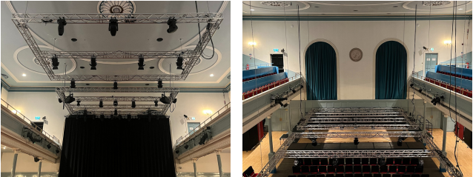

View of truss in raised position View of truss in lowered position
Parking

Access for load ins to the hall are heavily restricted due to the main front access being on a main, busy, arterial route with a bus lane, and the rear being on a main access road which is also heavily policed by the parking authorities employed by Edinburgh City Council.

Access to the front-Clerk Street

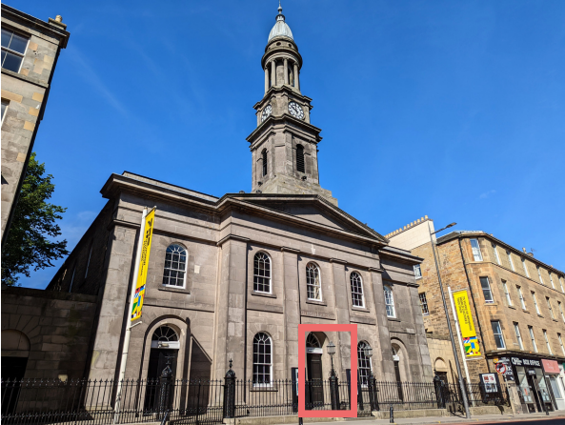

The main load in is through the middle black doors, show in coral above.
There is a two-step lift, over which a ramp can be acquired from the house. Then a small ramp into the foyer, followed by a push of approx 5 metres into the main auditorium floor. The stage is c. 20 metres from the foyer.

Access to the rear -Hope Park Crescent

This access is narrow (9.5ft / 290cm at narrowest point), steep and allows for max 3 (short) car lengths. The access must be kept clear at all times as it is the main fire escape from the rear of the building. From here there is a steep uphill push of c.8 metres to rear cafe doors then through cafe into backstage and stage right is another c.10 metres.

This access is discreet and well-hidden but can be found either by, if coming from the south, just after the traffic light junction look for a blue plaque on the buildings to the right.

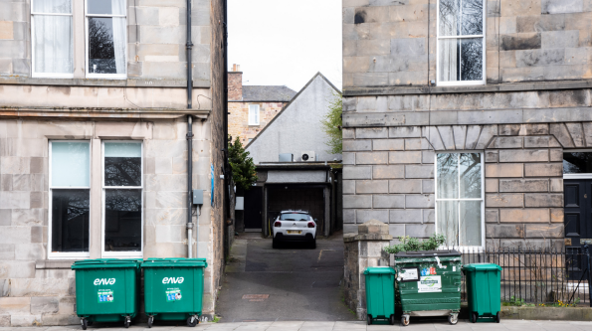

Or if coming from the north, a small well-hidden gap on the left, immediately after the traffic light controlled pedestrian crossing and before the bus shelter.

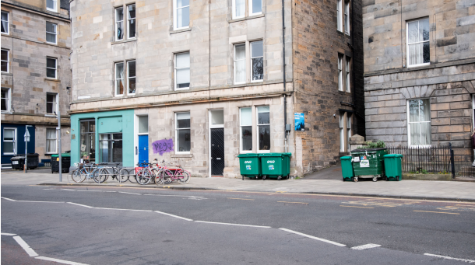

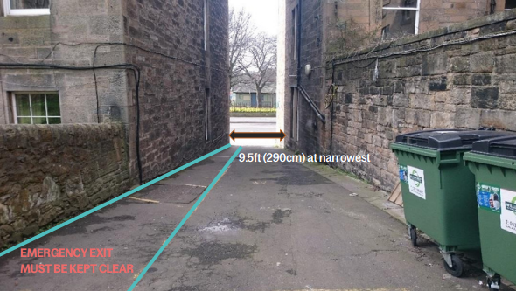

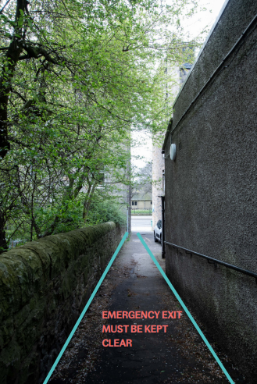
All marked areas are to be kept clear at all times for emergency access from the rear of the building.

Bar entrance/fire exit

Bus Lane Restrictions

Access to the front main load in is not available 07:00-09:30 and 16:00-18:30. During these times you will NOT be allowed to stop.

We do no permit overnight arrival and parking up outside the venue, as the bus lane timings will inevitably require early removal, and we cannot provide shore power overnight without compromising the security of The Queen’s Hall.

This is a residential area. Vehicles cannot be left running overnight for noise complaint reasons.

Load off dispensation

Dispensation does not apply to bus lane times stated above. During this time, you will need to source alternative arrangements for daytime parking, or risk a parking ticket (see options below).

Each dispensation application is £20 + VAT per vehicle.

This must be done at least 48 hours in advance of the date of arrival through the local authorities.

Parking authority contacts for further info / enquiries:

+44 (0)131 557 6941 | edinburghdispensation@nslservices.co.uk

Commercial lorry / bus parks

Pringles Coach Park
Leith Mills, 70-74 Bangor Road, Edinburgh EH6 5JU | www.pringlescoachpark.com
Contact - Jim Ballantyne: +44 (0)7770 991916 | jim@pringlescoachpark.com
Secure coach parking. Buses, rigid trucks up to 18 tons, vans, motorhomes.

The Britannia Coach & Truck Park
200 Sir Harry Lauder Road, Portobello, Edinburgh EH15 2QA
Contact - Brenda Sutherland: +44 (0)131 669 1911 | brenda@securecoachpark.co.uk

Marketing Support
(Updated Mar 2024)

We are delighted that you're bringing your show to The Queen's Hall and want to help you sell as many tickets as possible. To support you in doing this we offer the following services and optional extras. Please note: we don't deliver marketing plans for individual shows. Charges for any optional services will be taken from your final settlement figure.

Your event listing
To list your event on our website, we will require the following:
- A landscape orientation image. This could be a photograph, illustration or graphic and should not contain text if it can be avoided. Min. dimensions 1680 x 945px. Max. file size 700KB. File format: JPEG
- Event description text, no more than 300 words
- We can also include pull quotes and embedded YouTube content if desired.

Print
We have street-facing and internal locations around our venue for print materials. We'll accept:
- Up to 10 A3 posters. Venue specific rather than full tours have more impact.
- 1 x A1 poster. Again, venue specific preferred.
We no longer take A5 flyers. Customers don’t pick them up and they end up in recycling.
Please ensure that our venue name is always written as: The Queen's Hall. Our postal address can be found on the next page.
** Please find our NEW full logo suite here and delete any old versions you may have.**
We are happy to design posters for you within our house brand guidelines, just let us know.
Social Media
- Tag our social media accounts in your posts and we will retweet/share.
- We create social media content for all shows when they are announced and in the run up to the performance. Please send us any publicity photos or graphics you have for your event so we can use these in our output.
- If you choose to set up a Facebook Event, please add The Queen's Hall as a co-host.
- We can produce one Facebook/Instagram paid advert for your show. Please reach out to discuss your budget for this. Minimum spend: £100. An admin fee of 10% of ad budget is chargeable for this.
- You can request access to our Meta Ads Manager account if you'd rather create an advert yourself.
Our monthly newsletter
We have over 37,000 subscribers and email them about new shows around pay day / end of month.
- We'll include your show in the body text of the newsletter free of charge.
- Highlight your show with a banner advert for £100 + VAT. 620 x 148 px.
- Highlight your show with an inline advert for £120 + VAT. Max. 50 words + image/logo

Solus emails
We don't share customer data, but can send email marketing on your behalf. We value our customers and prefer to tailor emails to past bookers of similar shows, rather than blanket emailing our entire database.
- We can send a solus email for your show for around £0.10 + VAT per customer emailed.
- For this, we require at least one image and up to 300 words of marketing copy.

Useful Local Contacts

For the best results, we recommend that you also undertake your own marketing campaign. The following are Edinburgh businesses we use on a regular basis. Please mention The Queen's Hall when booking for the best rates.

Please note that these are suggestions only and we cannot take responsibility for the quality of work, or outcome resulting from, use of third party providers.

Print and distribution
- Hanging Rock A3 poster print & distribution | bobby@hanging-rock.co.uk
- Pace Print Printing | +44 (0)131 667 0737 | paceprintltd@btconnect.com
- Take One Media Leaflet distribution, school group target marketing | +44 (0)131 469 4874 | malcolm.gordon@menziesdistribution.com
- Direct Distribution A3 posters, flyer distribution, promo, printing, etc. | +44 (0)141 445 8838 | info@directdistribution.co.uk

Print and digital advertising
- The List Jayne Atkinson | +44 (0)7734 320319 | jayne.atkinson@list.co.uk
- The Skinny Sandy Park | +44 (0)131 467 4630 | sandy@theskinny.co.uk
- SNACK Kenny Lavelle | +44 (0)141 632 4641 | kenny@snackpublishing.com
- Canalside / South Edinburgh Directories Victoria Cowan | +44 (0)131 444 1429 | victoria@cowancommunitypublications.co.uk
- The Edinburgh Reporter Phyllis Stephen | +44 (0)7791 406498 | editor@theedinburghreporter.co.uk
- Art Mag Christie Dessy | +44 (0)131 475 1321 | publisher@artmag.co.uk

Press Contacts
You can access a list of journalists who are happy to be contacted directly about shows coming to The Queen’s Hall here.

To discuss further, please get in touch with our marketing team:
Emma Mortimore, Marketing & Development Manager: emmam@queenshalledinburgh.org +44 (0)131 622 7381
Becky Love, Marketing Officer: beckyl@queenshalledinburgh.org +44 (0)131 589 2998
The Queen's Hall, 85-89 Clerk St, Edinburgh EH8 9JG

